
UNIVERSITY OF MANAGEMENT AND TECHNOLOGY
Software Engineering Assignment: 4, CLO:4
Total Marks: 10

Instructions:
- Submit your assignment on LMS as well as in hard copy.
- No submission will be considered after the due date.

Question 1: 10+10
Create low and high-fidelity prototypes of your project. ;
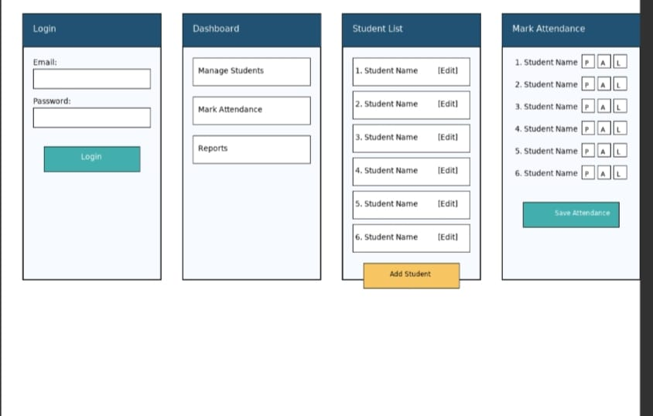

Github id
https://github.com/Usman8332394

